Accessibility Champions Syllabus
Course Information
This syllabus describes the requirements and procedures for Accessibility Champions. You are responsible for knowing this material, so please read it carefully. Any changes will be announced via email and Blackboard Ultra Announcement. You will be responsible for any changes. Your continued enrollment in this course is your implicit agreement to abide by the requirements of this class.
Contact Information
Name: Dr. Kristi Embry
Email: Kristi.embry@und.edu
Office Location: O’Kelly 330
Course Description
This course is designed to introduce Accessibility Champions to several of the most common digital document accessibility issues as well as their technological fixes.
Course Objectives
After successfully completing this course, you should be able to:
--Define accessible headings and create them in in a variety of document types
--Define accessible color and use accessible color in in a variety of document types
--Define accessible lists and create them in a variety of document types
--Define accessible links and create them in a variety of document types
--Define accessible tables and create them in a variety of document types
Minimum Technical Skills & Computer Requirements
To succeed in this course, you should be able to:
Navigate in and use Blackboard functions like submitting an assignment, taking a quiz, and locating resources
*Download and open electronic documents
*Create, save, and upload/attach electronic documents
*Send, receive, and manage email
Visit https://und.teamdynamix.com/TDClient/2048/IT/KB/ArticleDet?ID=87214 for additional supports and information about general tech requirements for students including information about devices, operating systems, software, internet connection, etc.
Course Resources
Please make sure to purchase The Norton Anthology of English Literature. Make sure to get the volume pictured below.
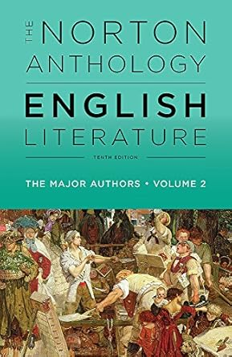
Assignments & Grades
The following sections outline the work that all students will need to complete to successfully pass this course as well as important information regarding the evaluation of said work. Please read carefully!
Assignments
You will complete four major assignments over the course of the semester. Full assessment descriptions can be found in Blackboard.
Quizzes |  | 15%
Written Essay #1 |  | 25%
Written Essay #2 |  | 25%
Exams | Midterm |  | 10%
Exams | Final |  | 10%
Attendance |  |  | 10%

Grades
The following grading scale will be used in this course:
A | 90-100%
B | 89-80%
C | 79-70%
D | 69-60%
F | 59%-below

Course Schedule
Fall 2025 Course Schedule
Class Date | Required Readings | Assessment Due Date
Monday, August 15 | Norton pp. 135-56  Broadview, pp. 2-6 | DRAFT #1 of Written Paper #1
Wednesday, August 17 | Norton pp. 135-56  Broadview, pp. 2-6
Friday, August 19 | Norton pp. 135-56  Broadview, pp. 2-6 | Final draft Written Paper #1

